**Laser ranging**

## 1. Learning objectives

In this course, we mainly learn to use STM32F103RCT6 and laser ranging module for ranging.

## 2. Prepare before class

The gesture recognition module adopts I2C communication, and connects the SDA and SCL of the module to the PB7 and PB6 pins of the STM32F103RCT6 board.

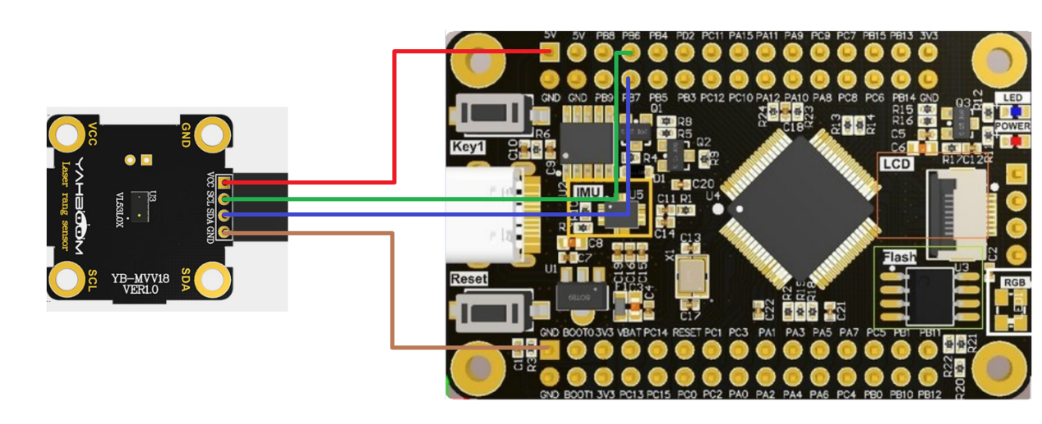

## 3. Program

Initialize the module

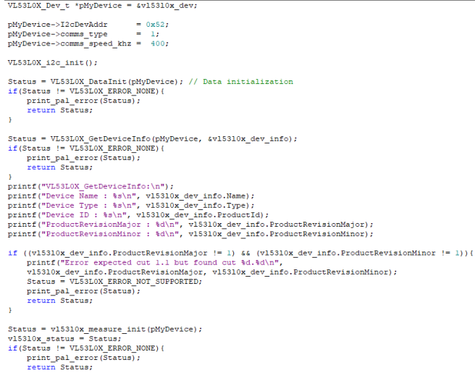

Microcontroller initialization

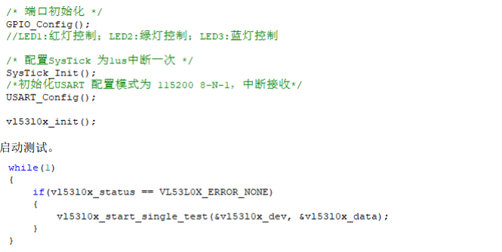

## 4. Experimental phenomenon

After the program is downloaded, the module is successfully initialized and the module name, ID and other information are printed, please check your own wiring when it fails. The detected distance is then printed in millimeters. The measuring range is 300mm-2000mm.